SETUP ENVIRONMENT :

FLASK CREATION

|  |  |
| --- | --- |
| TEAM ID | PNT2022TMID50137 |
| TEAM LEAD | Gokul S |
| TEAM MEMBER 01 | Jesu Denison K |
| TEAM MEMBER 02 | John Prakash I |
| TEAM MEMBER 03 | John Stephen J |

Flask install

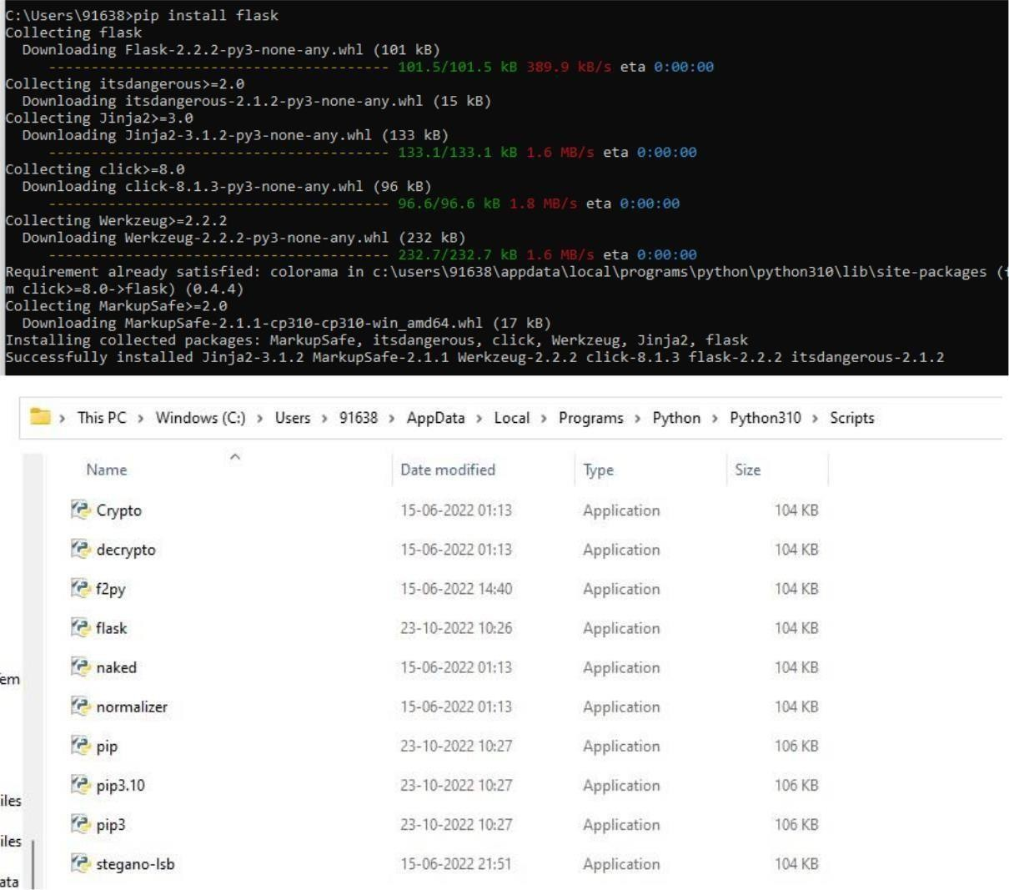

**Create flask:**

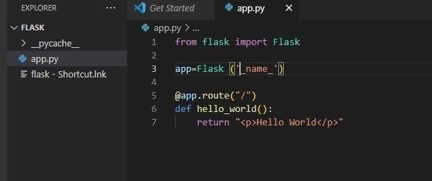

Run flak:

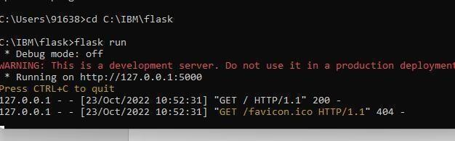

Output

